Trigonometry Homework #1
In 1 – 4, find the sine, cosine, and tangent of the angle given. Fill in your final answers in the answer blanks.
(Hint: Use the Pythagorean Theorem to solve for the unlabeled side.)
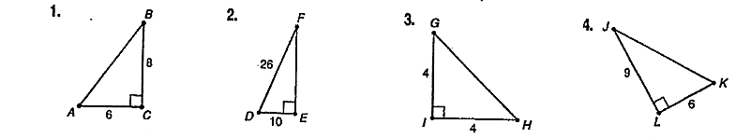

sin A = _________ sin D = ________ sin G = _________ sin K = ________
cos A = _________ cos D = ________ cos G = _________ cos K = ________
tan A = ________ tan D = _________ tan G = _________ tan K = ________

In 5 – 12, use a calculator to find the value correct to three decimal places (to the nearest thousandth).
5. $\sin{52°}$ 6. $\cos{8°}$ 7. $\tan{72°}$ 8.$\sin{18°}$

9.$\cos{58°}$ 10. $\tan{34°}$ 11. $\sin{62°}$ 12. $\cos{25°}$

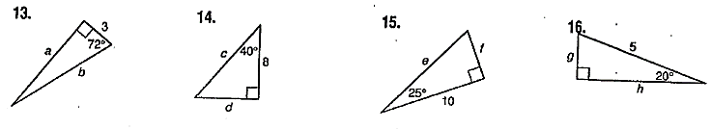
In 13 – 16, find the length of the labeled sides (the missing variables). Round to the nearest hundreth.

a = ________ c = ________ e = ________ g = ________
b = ________ d = ________ f = ________ h = ________

17. A train is traveling up a slight grade with an angle of inclination of only 2$°$. After traveling 1 mile, what is the vertical change in feet?

In 18 & 19, use the figure of the lighthouse. (Hint: draw the triangle for each problem frist)
18. At 2 p.m., the shadow of a lighthouse is 22 feet long and the angle of elevation
is 72$°$. Find the height of the lighthouse.

19. At 6 p.m., the angle of elevation of the sun is 40$°$. Find the length of the
shadow cast by the lighthouse.

