Name: ____________________________ Hour: _____________

Similarity Test Review

1. Is *JKLM* similar to *NOPQ*? Explain why or why not.

 

2. Is *JKLM* similar to *RSTU*? Explain why or why not.

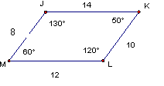

3. ∆DOG~∆CAT. Determine the following measurements. **Show all your work.**

m<D = ________ GO = ________ CT = __________



50®

In Questions 4 – 7, for each situation:

* Draw a picture if one is not drawn for you
* Show all work that you performed to determine your answer.

4. A flagpole 5 meters tall casts a 3-meter shadow. At the same time of day, a nearby building casts a 32-meter shadow. How tall is the building?

5. Miranda is 5 feet tall. She casts a 6 foot shadow at a particular time of day. How tall is her friend if, at the same time of day, his shadow is 1 feet taller than hers?

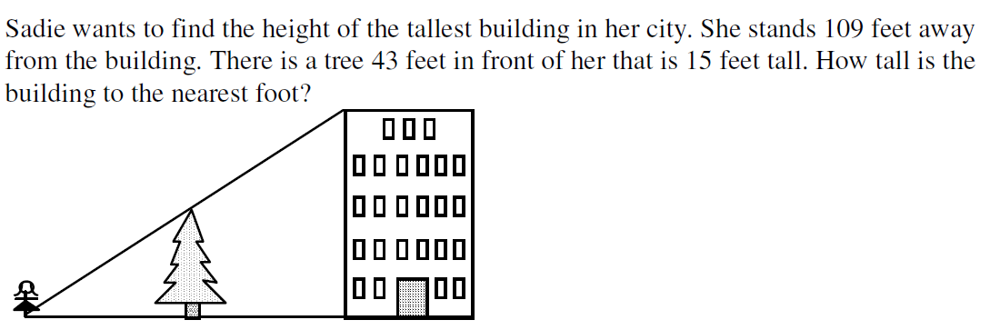

6.

7. Scott placed a mirror on the ground between himself and his neighbor's house stood so that he can see into one window. The mirror is 2.43 meters from his feet and 9.32 meters from the base of the other house. Scott's eye is 1.85 meters above the ground. How high is the window?

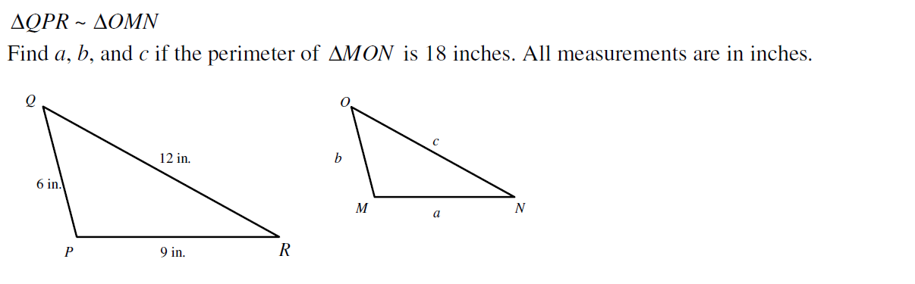8.

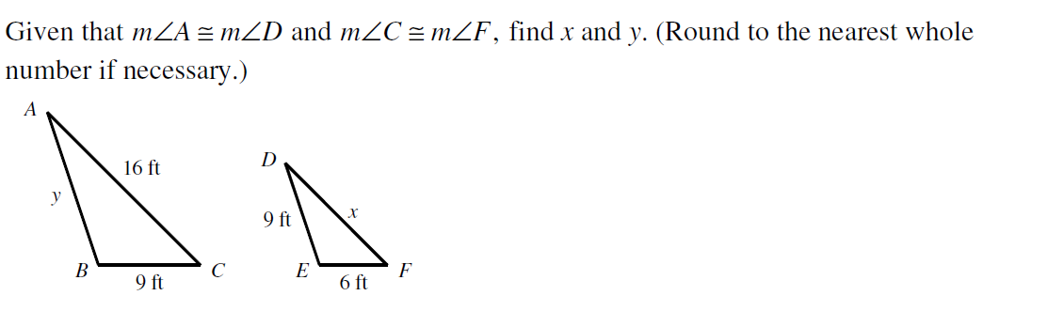9.

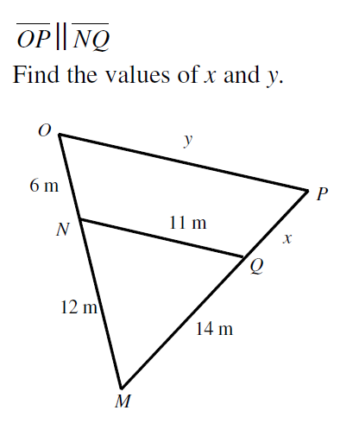

10. 11. Graph the given points and draw   
the image under dilation with the center at the origin and the scale factor of 2.

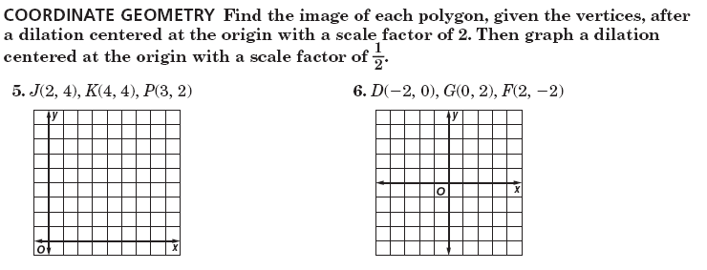

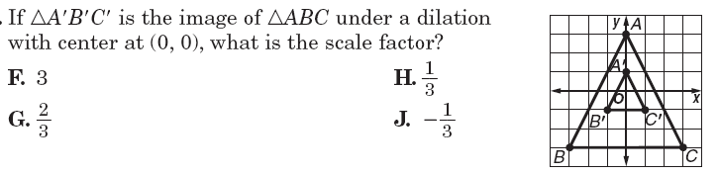12. Draw the image of $∆MNO$ under a dilation 13. If $∆A^{'}B^{'}C^{'}$ is the image of $∆ABC$ under a   
 with the center C and a scale factor of 2. dilation centered at the origin, what is the  
 scale factor? Is it a reduction or enlargement?

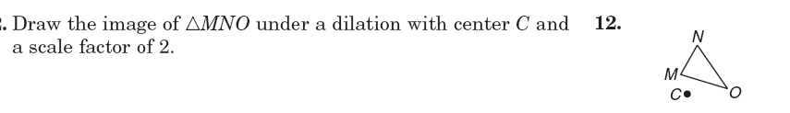

14. What are the two things you must have in order to have similar polygons?

15. a. If two polygons are congruent, are they also similar?

b. If two polygons are similar, are they also congruent polygons?

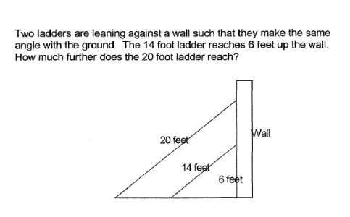16. Two ladders are leaning against a wall such that they make the same angle with the ground. The 14 foot ladder reaches 6 feet up the wall. How much further does the 20 foot ladder reach (than the 14 foot ladder)?

17. There are 182 girls in the sophomore class of 305 students.   
 a) Find the ratio of boys to girls in the sophomore class.   
 b) Find the ratio of boys to the sophomore class.   
 c) Find the ratio of girls to the sophomore class.

18. There are 27 oranges and 18 grapefruit in a fruit bowl. What is the ratio of oranges to grapefruit?

19. The ratio of the perimeters of two similar rhombii is 12:13. The larger rhombus has a side length of 60 inches. Find the side length of the smaller rhombus.

20. If , find 21. If *PQR*  *STU*, find *x*.

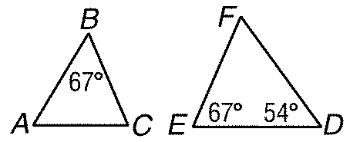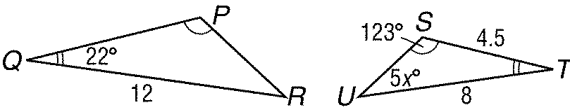

22. Identify the similar triangles. State the similarity postulate (shortcut) used to prove they are similar. Find *MN*.

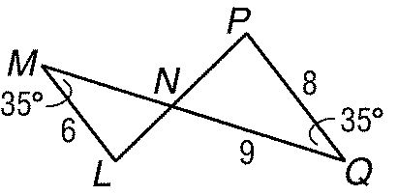

23. Find *QT*. 24. Find x.

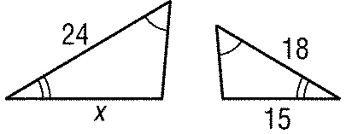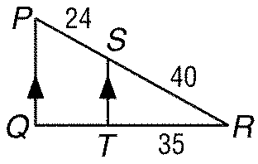

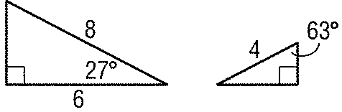29. In *ABC* *AB*  *MN*. What is *x*? 25. Which theorem/postulate can be use to prove that these two triangles are similar?

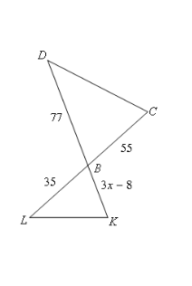26. If find x.

27. If find x.

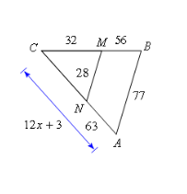

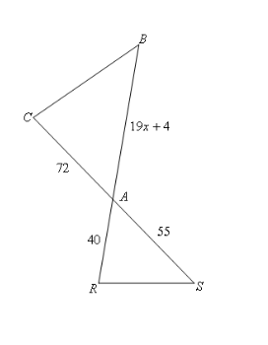28. If find x.