Review for Quadratics Test Name:______________________________
All work must be shown in order to receive any credit.

____ 1. The related graph of a quadratic equation is shown below. Use the graph to determine the solutions of the equation.

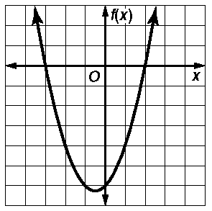

a. |  | c. | 3, 2
b. | 0, | d. | 0, 2

____ 2. Identify the quadratic function graphed below.

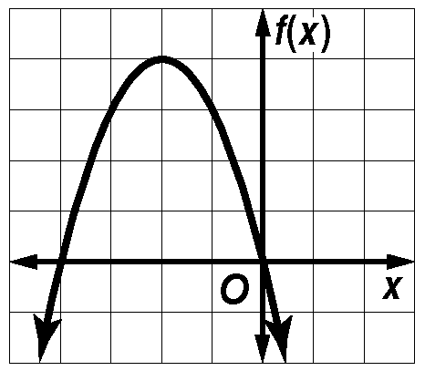

a. |  | c.
b. |  | d.
b. |  | d.

.

3. Write a quadratic equation with 4 and 7 as its roots. Write the equation in the form
ax² bx c 0, where a, b, and c are integers.

4. Lina and Kristin are solving . Who is correct? Explain your reasoning.

Lina | Kristen
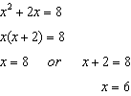 | 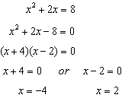

.
5. PHYSICS The height h (in feet) of a certain rocket t seconds after it leaves the ground is modeled by
h(t) 16t² 64t 12. Write the function in vertex form and find the maximum height reached by the rocket.

6. The path of the water from a sprinkler is modeled by the quadratic function , where h(d) is the height of the water, in feet, at a distance d feet from the jet. Find how far from the sprinkler the water hits the ground.

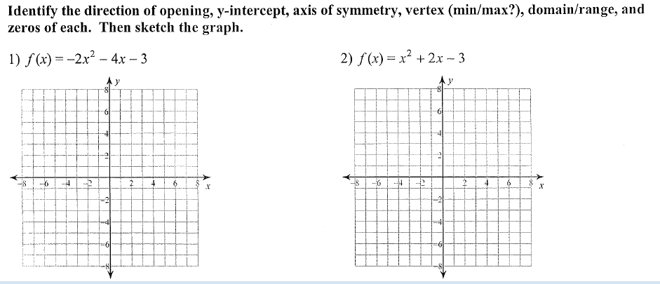

Opens up/down: __________ Opens up/down: __________

y-intercept: __________ y-intercept: __________

axis of symmetry: __________ axis of symmetry: __________

vertex: __________(max/min?) vertex: __________(max/min?)

domain and range: __________ domain and range: __________

zeros: __________ zeros: __________

