Converse of the Pythagorean Theorem and Special Right Triangle Practice

Determine if the following sides form a right triangle. Then state if they form a Pythagorean Triple.
- 60, 80, 100 2. 45, 60, 76 3. 2, 4, $\sqrt{20}$

Right triangle? ___________ Right triangle? ___________ Right triangle? ___________
Pythagorean Triple? _______ Pythagorean Triple? _______ Pythagorean Triple? _______
Use special right triangles to find the missing sides.
4. 5. 6.

7. 8. 9.

10. 11. 12.
y
x

$$6\sqrt{2}$$

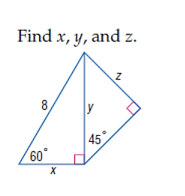
13. 14. 15.

