**Graded Individual Practice: or QUIZ**

**Constructions of Rotations and Reflections**

Reflect the given figure over the given line.

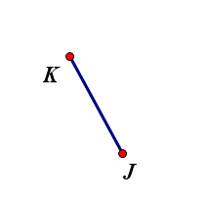

1.

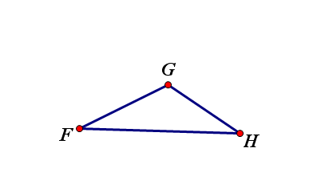

2.

**Rotate the given figures around the point of rotation, point R.**

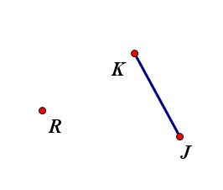3. Rotate 85° clockwise

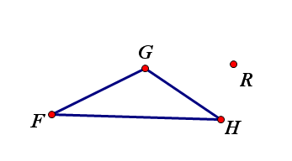4. Rotate 125° counterclockwise