**C:\Users\Kelly\AppData\Local\Microsoft\Windows\Temporary Internet Files\Content.IE5\ORFY33ML\MC900434399[1].wmfAngle Relationships: Notes**

**Justifications**

***Justification:*** *Vertical angles are congruent!*

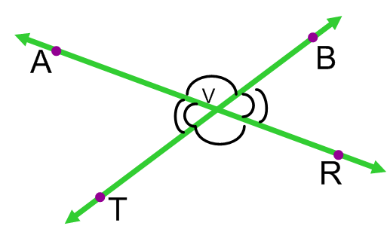**1.** Name the vertical angles which are congruent.

**2.** What is an angle bisector? ___________________________________________________________

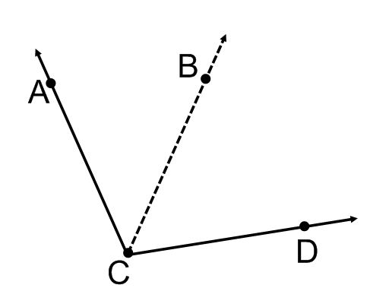 If $\vec{CB}$ is an angle bisector, state what is true about the figure.

***Justification:*** *Definition of Angle Bisector*

**3.** Use the same figure, but DO NOT assume Ray CB is an angle bisector: If *m<ACB=64ᵒ* and *m<BCD=33ᵒ* find the *m<ACD*.

***Justification:*** *Angle Addition*

**4.** Adjacent angles are angles which share a common vertex and a common side, we commonly say angles next to each other. Draw an adjacent angle to <ABC, which shares vertex B and side $\overline{BC}$.

**5.** Straight Angle measures _______________. Draw an example of straight angle <NJB.

***Justification:*** *Definition of straight angle.*

**6.** Linear Pairs

***Justification:*** *Linear Pairs are Supplementary*

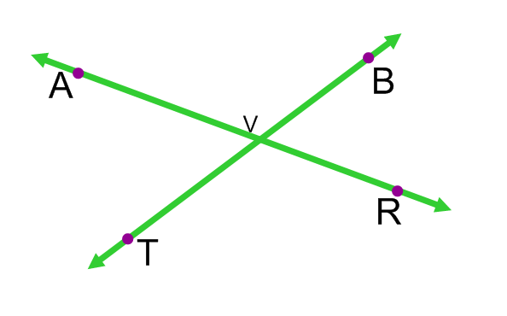

**7.** Draw $\overset{⃡}{FR}⊥\overset{⃡}{EB}$ which intersect at X.

***Justification:*** *Definition of Perpendicular*

**8.** Draw $<HGT$ as a right angle.

***Justification:*** *Definition of Right Angle*



**9.** **Using Justifications:**

Given: $\vec{CB}$ is an angle bisector

Prove or Show: 2 $<ACB=<ACD$ and $<ACB=\frac{1}{2}<ACD$

**Angle Relationships: Examples**

**Directions:**

*Draw a picture if one is not provided and find the measure of the angle.**Justify your reasoning!*

**1.** If <1 and <2 are a linear pair and *m<1= 78ᵒ,* find the m<2.

**2.** If <1 and <2 are vertical angles and *m<1= 78ᵒ*, find the m<2.

**Directions**: Find the measurement of the given angle.

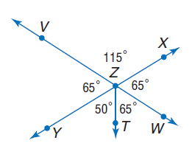**Use the figure to the right. Show Geometry and justify your SET UP!**

**3.** m<VZT **4.** m<XZT

**5**. m<WZY **6.** m<VZW

**Directions**: Find the measurement of the given angle. If the m<1=65ᵒ

**Use the figure to the right. Show Geometry and justify your SET UP!**

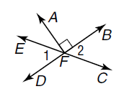

**7.** m<2 **8.** m<DFC

**9.** m<EFB **10.** m<EFA

**Show Geometry and justify your SET UP!**

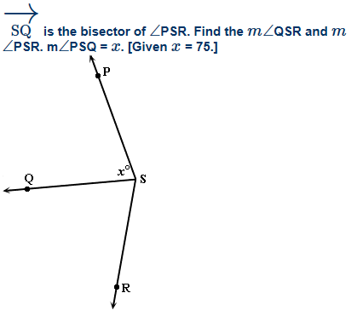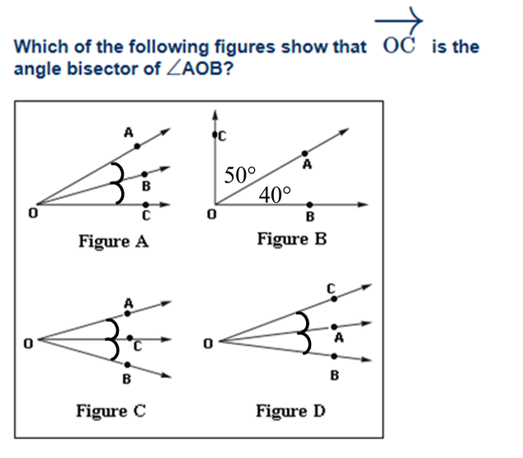11. 12.

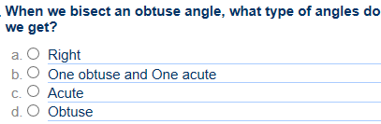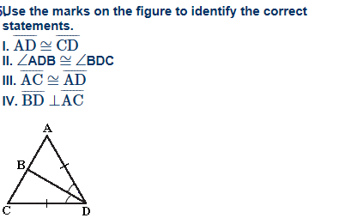13. 14.



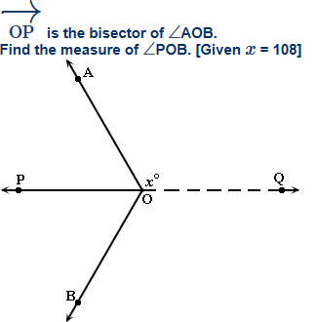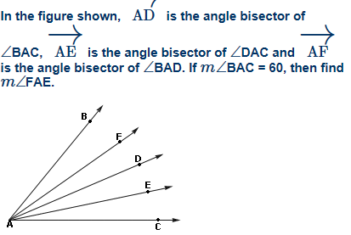

15. 16.

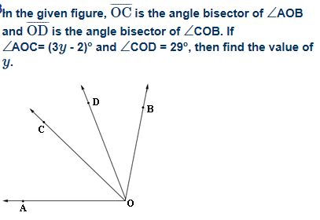17.