Midterm Review 2016-2017 Name:__________________________
Date: _______________Hour:______
Part 1: Linear/Systems
- Solve the following equations for the indicated variable.
a) x – y = –4, for y b) 7A + 8B = 24, for B

c) 6f – 7d = 28, for f d) 11p – 6r = 24, for p

- Sam needs to buy breakfast for his study group. The equation 0.80x + 1.50y = 12 models how much money he will spend on bagels and muffins. Let x = number of bagels and y = muffins.

  - If this equation were graphed, what would be the x-intercept? The y-intercept?

  - What would the x-intercept represent? What would the y-intercept represent?

- Sam needs to buy breakfast for his study group. The equation 0.80x + 1.50y < 12 models how much money he will spend on bagels and muffins. Let x = number of bagels and y = muffins Which statement below is true?

Sam will purchase 12 items. Bagels are on sale for 20% off.
Sam will spend at most $12. Sam can purchase 2 bagels and 8 muffins.

- Georgia needs to buy craft supplies. The equation 0.75x + 2.25y < 20 models how much money she will spend on glue sticks and glitter pens. Let x = number of glue sticks and y = number of glitter pens. Tell what each component of the equation means in context.

0.75x 2.25y 20 <

- Which of the following inequalities is NOT a constraint for the solution region shown?

  - a) x ≥ 0 b) y ≥ 0 c) x + 3y ≤ 9 d) x – 3y ≥ 9

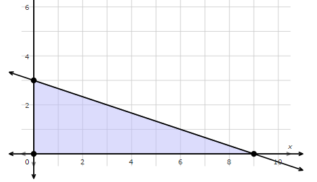

- Which of the following inequalities is NOT a constraint for the solution region shown?
a) 2x + y ≥ 10 b) x ≤ 10 c) x – y ≥ -7 d) 2x – y ≥ 2

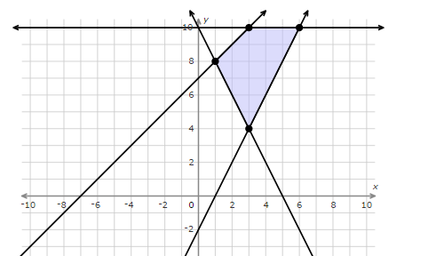

- MJR is selling Movie tickets. The theater must sell at least 200 student tickets. The theater must sell at least 150 adult tickets. The theatre will hold 850 people.

What are the constraints for this scenario?

- Sally is in the band and is selling bagels for $2.00 and slices of pie for $3.50. She has a goal of selling $28 worth so she can attend the field trip to the Detroit Symphony Orchestra. Graph this inequality | - The theater department is selling tickets to the musical. They must sell at least 300 student tickets and at least 100 adult tickets. The auditorium will hold 900 people. Graph the following constraints.  x ≥ 300 y ≥ 100 x + y ≤ 900

- Juan makes two types of wood clocks to sell at local stores.
  - It take him 2 hours to assemble a pine clock, and 2 hours to assemble an oak clock. Juan has 20 hours that he can work on clocks.

  - A pine clock requires 1oz of varnish, and an oak clock requires 4oz of varnish. Juan has 16oz of varnish in stock.

  - Let x = pine clocks, and y = oak clocks.

  - What are the two constraints? _______________________

_______________________

  - Graph the constraints.

  - If he make $3 profit on each pine clock and $4 profit on each oak clock. Use the function f(x, y) = 3x + 4y to determine how many of each type he should make to maximize his profit?

Solve the following systems using either substitution or elimination (addition/subtraction).

- x – 4y = 8  x – y = –4 | - 12x + 5y = 45  12x + 5y = –5
- x – y = –5  5x + 3y = –9 | - 10x + 6y = 18  5x + 3y = 9
- 3x – 2y = 14  5x + 4y = 16 | - 11x – y = 5  x – y = –5

- Fill in the missing interval for the piecewise function.
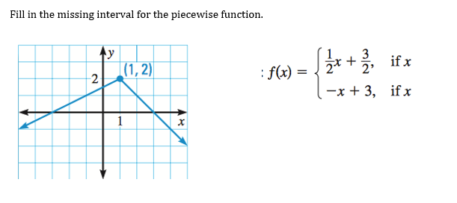

- Write the equation of each piecewise function.

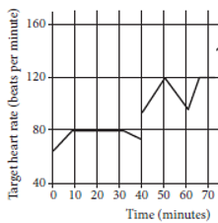
- On which intervals is John’s target heart rate strictly increasing?

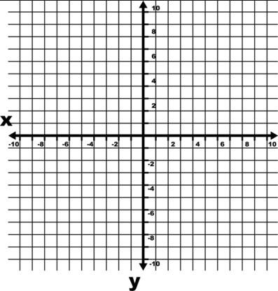
- Solve the system below by graphing.
x y 5
2y x 2

- Write a scenario, using the graph below, for two companies’ services. Be sure to include which company would be a better buy before the break-even point, and which company would be a better buy after the break-even point. Also, what is the break-even point and what does it mean?
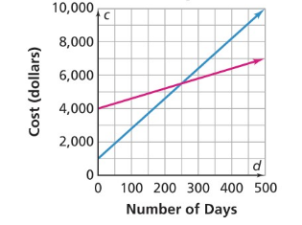

- Consider the system of equations below. What multipliers would you use on both equations if you wanted to eliminate the x terms? What multipliers would you use on both equations if you wanted to eliminate the y terms?
$$5x+2y=10 \\ 3x-4y=12$$
- Alex buys 6 Power Bars and 2 jars of Creatine for a total of $128.00. Nicko buys just 2 Power Bars but buys 4 jars a Creatine for a total of $76.00. How much does each product cost?

- John has 20 meal coupons for McDonalds and Burger King.
- McDonald’s coupons are worth $2 and Burger King’s coupons are worth $2.50.
- He has a total of $44 worth of coupons, find the number of McDonald’s coupons John has.

- Write a system of equations, in slope intercept form, for each of the scenarios, and sketch a graph:
Exactly one solution No solution

Infinitely many solutions Exactly two solutions

- Using the graph of a system of inequalities below, determine if the ordered pairs fall in the solution set or not (yes or no).
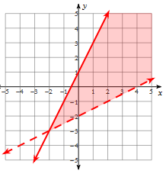
a) (0, -2) __________
b) (0, 1) __________
c) (2, 1) __________
d) (4, 0) __________
e) (-2, -3) __________
f) (3, 4) __________
Part 2: Matrices Name:__________________________
- Tell if the following matrices can be multiplied and if they can what is the dimension of their product.
Matrices Can you Multiply? Dimension of product
a) $\left[A\right]$ 2 x 3 $\left[B\right]$ 3 x 4
b) $\left[A\right]$ 2 x 3 $\left[B\right]$ 2 x 2
c) $\left[A\right]$ 3 x 3 $\left[B\right]$ 3 x 4
d) $\left[A\right]$ 5 x 5 $\left[B\right]$ 5 x 5

- Write a matrix for the given information.
      - Make a 3 x 3 Matrix
Taco Bell Store Sales:
Store #1 Burritos 20, Tacos 76, Drinks 12
Store #2 Burritos 35, Tacos 53 Drinks 18
Store #3 Burritos 24, Tacos 60, Drinks 21

B) Make a 2 x 3 Matrix
Bakery Inventory:
Store #1 Donuts 34 Muffins 45
Store #2 Donuts 13 Muffins 55
Store #3 Donuts 31 Muffins 4

- 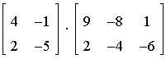, if possible.

- $\left[\begin{matrix}2 & -3 \\ 4 & -5\end{matrix}\right]$ $\left[\begin{matrix}a & 2 & -5 \\ 0 & b & c\end{matrix}\right]$

- $\left[\begin{matrix}3 & -1 \\ 0 & 5\end{matrix}\right]\left[\begin{matrix}a & 3 \\ c & -b\end{matrix}\right]$

- What is the identity for a 2 x 2 matrix? For a 3 x 3 matrix? For a 4 x 4 matrix?

- How can you tell if two matrices are inverses?

- What do you know about the product of $\left[A\right]∙{\left[A\right]}^{-1}$

- Solve the matrix equation 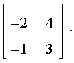 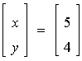 by using inverse matrices.

- Solve the matrix equation 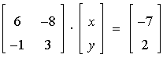 by using inverse matrices.

- Write a matrix equation for the following system of equations

3f 2g 7 and 2f g -5?

- Write a matrix equation for the following system of equations
5m – 2n 13 and m n 2?

- Write an example of two matrices, and their dimensions, which can be multiplied. Then, write an example of two matrices, and their dimensions, which cannot be multiplied.

- Simplify
        - $\left[\begin{matrix}1 & 2 \\ 3 & 4\end{matrix}\right]+\frac{1}{3}\left[\begin{matrix}3 & 6 \\ 9 & 3x\end{matrix}\right]$

        - $\left[\begin{matrix}2 & -3 \\ 4 & -5\end{matrix}\right]-2\left[\begin{matrix}2 & 8a \\ 4 & -6b\end{matrix}\right]$

Part 3: Quadratics Name:______________________
- Simplify $\sqrt{-200}$.

A. 2i$\sqrt{10}$ | B. –10i$\sqrt{2}$ | C. 10i$\sqrt{2}$ | D. –2i$\sqrt{10}$

- Simplify $\sqrt{-50}$

- Simplify $\sqrt{-27}$

- What is the conjugate of $\frac{ 3}{-2-5i}$ of the denominator?
A. 2 + 5i | B. –2 + 5i | C. –2 – 5i | D. $\sqrt{-2-5i}$

- What is the conjugate of 2 +2i ?

- What is the conjugate of 3 -4i ?

- Simplify (–4i)•( –2i)
A. 8i | B. –8 | C. –8i | D. 8

- Simplify. YOU MUST SHOW ALL YOUR STEPS!

(2 - 2i)(1 + 3i) (2 - 2i)(1 + 3i)

(12i)(5i) (- 2i)( 6i)

For #49-51, use the Quadratic Formula or Completing the Square to find the exact solutions of the following Quadratics.
- 2x² – 16x + 33 = 0 50. $x^{2}-3x+5=0$

- $x^{2}+6x+7=0 51. x^{2}-7x+8=0$

52. Find all of the zeros of the function f(x) = x² + 6x + 13.

A. –2 + 3i and –2 – 3i | B. –13 and 0 | C. –3 + 2i and –3 – 2i | D. No Solution

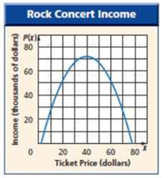
53. Use the diagram about Rock Concert Income.

- What is the coordinate of the vertex?

- Write an equation that could model the graph. Use an a-value of $-\frac{1}{7}$.

54. A coin is dropped from the top of a building. The height of the coin as it falls is represented by the function h(t) = -16t² + 800 where h = height above the ground in feet and t = time in seconds.

What is the time when the coin is at its maximum height? Explain how you know.

What is the maximum height of the coin? Explain how you know.

At what time will the coin hit the ground? Explain how you know.

55. Write a quadratic equation with 6 and $\frac{3}{4}$ as its roots.
Write the equation in the form ax² bx c 0, where a, b, and c are integers.

56. Which quadratic equation has roots 2 and 3?
a. c.
b. d.

57. Which quadratic equation has roots 2 and ?
a. x² 4x 4 0 c. 5x² 9x 2 0
b. 5x² 9x 2 0 d. 5x² 11x 2 0

Part 4: Conics Name:______________________

58. What does the value of k have to be in order for the quadratic function to have two real solutions?
y = –3(x – 5)² + k

59. Identify the range for y = 2.5 (x + 3)² – 2.
A. y > –2 | B. y > 2 | C. y < 2.5 | D. y < 3

60. Identify the range for y = –3(x – 5)² + 8

Solve the following systems of a quadratic and a linear equation:
61. $y=x^{2}-x-4$  $$y=2x$$ | 62. $y=x^{2}-3x+2$  $$y=x-2$$ | 63. $y=x^{2}-5x+11$  $y=2x+1$

64. Write an equation for a quadratic in the form $y={\left(x-h\right)}^{2}+k$ that has a vertex at…

- (1, -7) __________________________________

- (2, 4) ___________________________________

- (-1, 7) ____________________________________

- (-2, -3) ____________________________________

- (0, 3) ____________________________________

Use complete the square to write the standard form of the parabolas below.
65. ${f\left(x\right)=x}^{2}+2x+4$ | 66. ${f\left(x\right)=x}^{2}+4x-4$ | 67. ${f\left(x\right)=x}^{2}-14x+1$

68. Identify the center and the radius of the following circles.
- ${(x-2)}^{2}+{(y+3)}^{2}=25$ center _________________ radius _______

- $x^{2}+{(y+5)}^{2}=81$ center _________________ radius _______

- ${(x-2)}^{2}+{(y+3)}^{2}=49$ center _________________ radius _______

- ${(x-3)}^{2}+y^{2}=36$ center _________________ radius _______

Use complete the square to write the standard form of the circles below.
69. $x^{2}+2x+y^{2}-6y=4$ | 70. $x^{2}-6x+y^{2}-8y=4$ | 71. $x^{2}+8x+y^{2}-6y=1$

