Exam Review Part 1 – Polynomials 2017 Name:____________________________________

Note to students
The semester assessment will test three content themes: polynomials and functions (36%), probability (31%), and statistics (33%). The semester assessment will provide you with the graphic organizer for a deck of cards shown below.

Perform the indicated operation.
- (4r² + 47r + 76) ÷ (r + 10) | - (7x² – 57x – 62) ÷ (x – 9)
- (6a³ – 11a² + 4a) ÷ (2a - 1)  Determine the number of zeros (x–intercepts). Tell the least degree of the polynomials.  5. 6.  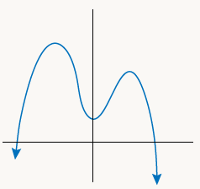  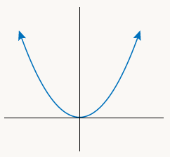 | 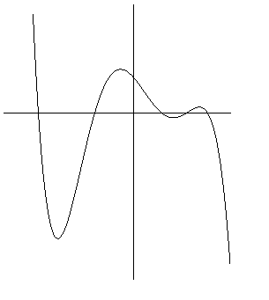  4. (x³ – 9x² + 27x – 27) ÷ (x – 3)  7.
Factor.
8. 12x³ + 5x²–2x | 9. 7x² + 41x – 6 | 10. 5x³ -70x² – 120x

Tell the degree of each function. Find exact solutions for each equation.
11. 2x³ – 5x² = 0 | 12. (x² – 25)( x² + 4) = 0 | 13. 8x³ – 20x² + 8x = 0 | 14.x²(x – 4)(4x – 1) = 0

15. Use technology to graph and identify the relative maximum and relative minimum. f(x) = 11x³ – 11x² + 9

A company makes wristwatches. If x watches are manufactured and sold, the cost is calculated by the function C(x) = 500 + 15x. The revenue is calculated by the function R(x) = 140x.

16. Find the profit from the sale of 1600 wristwatches.

17. Which combination of functions can be used to calculate the profit from the sale of the watches?

- (C + R) (x) | - (R – C) (x) | - C(x) ⋅ R(x) | - R (C (x))

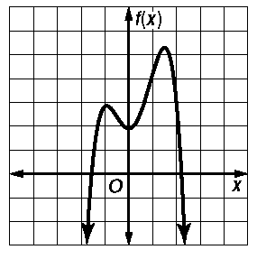
18. Use the graph shown. Estimate the x–coordinate at which a relative minimum occurs.
- –1
- 1
- 0
- 2

19. Estimate the x–coordinate at which the relative maxima occurs for the function, f(x)= –(x + 1)(x – 1)(x – 2).

Match the graph to the equation.
20. | 21.
22.
23.

24. If g(x) = 2x – 1 and h(x) = x² – 1, find (g–h)(0)

25. If g(x) = 3x – 1 and h(x) = x³, find (g⋅h)(–1)

26. If g(x) = 2x – 1 and h(x) = x² – 1, find g(h(5))

27. If g(x) = 3x – 1 and h(x) = x³, find h ⃘g (1)

28. If g(x) = –2x – 4 and f(x) = x² + x, find g(f(9)).

29. If g(x) = 3x – 1 and f(x) = 4x – 5, find g⃘$∘$f (0)

Find the inverse.
30. y = x² – 4 | 31. y = $\frac{x^{3}}{5}$ | 32. y = $\sqrt{\frac{x+2}{9}}$
33. g(x) = –3 + $\frac{3}{5}$x | 34. h(x) = $\frac{-x-3}{6}$ | 35. f(x) = $\frac{x^{2} – 4}{10}$

Simplify. Your answer should contain only positive exponents.
36. 2a^{–4}b²⋅2a^{–3}b^{–1} | 37. 4a^{–4}b^{–1} ⋅ 3a³ ⋅ 3a⁴b^{–3}
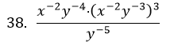 | 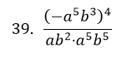

40. The dimensions of a picture within a frame are shown in the diagram. The width is twice as long as the height. If the width is increased by 4, the height stays the same, and the area within the new frame is 160 in², what are the original dimensions of the frame?
2x
x

Below are the equations for the volume of a box. Solve for the dimensions of the box.
41. x (x – 4)(3x + 4) = 264 | 42. 210 = x(x² + 1)(2x + 1)

Exam Review Part 2 – Probability 2017
Note to students
The semester assessment will test three content themes: polynomials and functions (36%), probability (31%), and statistics (33%). The semester assessment will provide you with the graphic organizer for a deck of cards shown below.

Standard Deck of Cards:
 | suit |  |  |  |  |  |  |  |  |  |  | face cards
red | hearts ♥ | ACE | 2 | 3 | 4 | 5 | 6 | 7 | 8 | 9 | 10 | Jack | Queen | King
 | diamonds ♦ | ACE | 2 | 3 | 4 | 5 | 6 | 7 | 8 | 9 | 10 | Jack | Queen | King
black | clubs ♣ | ACE | 2 | 3 | 4 | 5 | 6 | 7 | 8 | 9 | 10 | Jack | Queen | King
 | spades ♠ | ACE | 2 | 3 | 4 | 5 | 6 | 7 | 8 | 9 | 10 | Jack | Queen | King

43. At work, you are assigned a three–letter identification code to get into a storage locker. What is the probability that the code will be the exact same letters and order as your initials?

44. If you know that the three digit code begins with an X and no letters are repeated, what is the probability that the next two letters are YZ (in that order)?

45. A blue die and a red die are tossed. What is the probability that a 6 will appear on both dice?

46. If one die is tossed and you know it is an even number, what is the chance that it is a two?

47. A jar contains 10 purple marbles and 2 red marbles. If two marbles are chosen at random with no replacement, what is the probability that 2 purple marbles are chosen?

48. A card is drawn from a standard deck of cards. What is P(heart or a 6)?

49. Troy is at an event where the party host is giving away prizes. There are two $10, two $20, and ten $30 gift certificates. If the host selects and gives away three certificates in succession, what is the probability that she will choose three $30 gift cards for the first three give-aways?

The table shows the attendance of 300 ninth graders over the past month.
Number of  Absences | Number of  Students
0 | 50
1 | 120
2 | 75
3 or more | 55

50. Find the probability that a randomly–chosen
ninth grader will be absent 2 days next month.

51. Find the probability that a randomly–chosen
ninth grader will be absent fewer than 2 days next month.

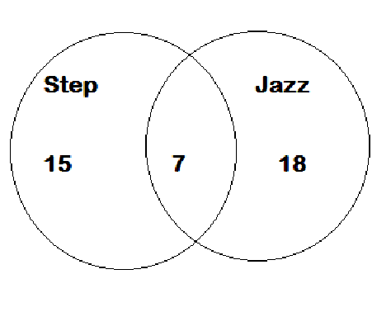
The diagram shows the number of participants in two different kinds of aerobic exercise classes offered at a health club.

52. P(step aerobics or jazzercise, but not both)

53. P(step aerobics and jazzercise)
54. Should P(jazzercise) = P(NOT step)? Explain why or why not.

Forty–four senior citizens were surveyed about music preferences. The results are displayed in the diagram.

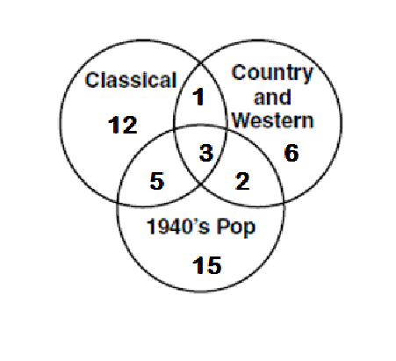
55. If a senior citizen from the survey group is selected at random, what is the probability that he or she likes
only country and western music?

56. If a senior citizen from the survey group is selected at random, what is the probability that he or she likes classical or country, but not 1940’s pop?

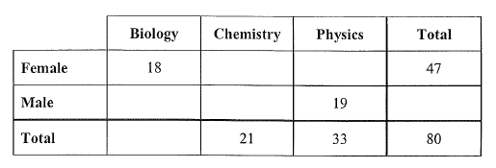
Complete the two–way table and find each probability.

57. P(student studies Physics) = ________

58. P(student does not study Chemistry) = ________

59. P(student is a female and studies Biology) = ________

60. P(student is a female or studies Biology) = ________

61. Given a person selected at random is female, what is the probability she studies chemistry? ________

62. If 1500 students that attend this school, approximately how many students study physics? ________

63. If 1500 students that attend this school, approximately how many students are female? ________

64. Fill in the table. Suppose a
student is chosen at random, Find the
following probabilities.
 | 9th grade | 10th grade | Total
Walk | 15 | 13
Bus |  | 33 | 54
Bike | 2 |  | 6
Car |  | 12 | 30
Total | 56 |  | 118

- P(walk or ride their bike to school) | - P(9th grade or walk to school)
- P(9th grade and ride their bike to school) | - P(9th grade or ride their bike to school)
- P(10th grade and ride their bike to school) | - P(ride their hover-board to school)
- Given a person chosen at random is a 10th grader, what is the probability he or she rides a bike to school?

- Given a person chosen at random rides his or her bike to school, what is the probability that person is a 10th grader?

Exam Review Part 3 – Statistics 2017
You should be able to define and use in application the following terms:
lower extreme (min) | lower quartile  (q₁) | mean | median  (q₂) | mode
upper quartile  (q₃) | upper extreme (max) | interquartile range (IQR) | range | standard deviation

65. As a math project, students are asked to collect data on a topic of their choice. One student wants to find out if bowling is popular in her community.
  - Give an example of a random sample for this situation.

  - Give two examples of a biased samples for this situation.

Mr. Thomas randomly surveyed his first hour and asked students how much time they spent in the shower. He gave them 5 choices, as shown in the table below. The table shows the results.
minutes | # responded
3 | 2
5 | 10
8 | 10
10 | 6
15 | 2

66. What is the average number of minutes spent in the shower by students in Mr. Thomas’ first hour?

67. What is the median number of minutes spent in the shower by students in Mr. Thomas’ first hour?

68. Corey thought Mr. Thomas was asking about something else and answered 30 minutes. Clearly, 30 minutes is an outlier compared with other data. If Corey’s data had been included in Mr. Thomas’ results, how would it have affected the value of the mean or median?

69. A survey was conducted and the results showed that 46% of Dakota High School students own a graphing calculator. There are 2,800 students at Dakota. If the margin of error for the survey results is 4%, calculate an interval for the number students who own graphing calculators.

70. Tim and Alicia are running against each other for Treasurer of the township in which they live. The local paper reports that 53% of people at the polling stations responded that they voted for Tim, but that there is a 3.5% margin of error in the survey results. Can Tim declare with certainty that he is the winner of the election? Why or why not?

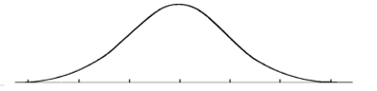
The height of 600 students follow a normal
distribution with a mean of 175 cm and a
standard deviation of 6 centimeters. Label
the normal curve to model this scenario.

71. What percent of students are between 169 and 181 cm tall?

72. What percent of students are between 181 and 187 cm tall?

73. What percent of students are shorter than 169 cm tall?

74. What percent of students are taller than 187 cm tall?

75. The table shows the amount spent on one meal.
$ on dining out
$ for one meal | # responded
$3 | 3
$5 | 10
$8 | 10
$10 | 7
$12 | 2
$15 | 4
$20 | 1

- Create a box plot for the data.

- Identify the interquartile range. What percent of the data
is in the IQR?

The box plot displays data for heights of dogs.
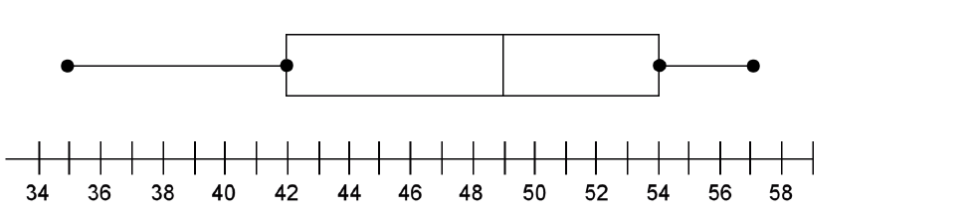

76. According to the box plot, what percent of dogs in the sample have a height of at least 42cm?

77. Does the data display tell you how many dogs were measured?

78. Does the data display tell you the avearage height for the dogs?

79. What information does the data display tell you?

80. The Box Plot above compares the number of minutes boys and girls take to get ready for school in the morning.
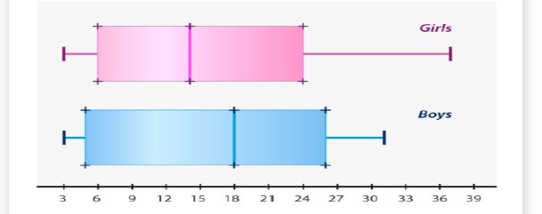
- Find the median time for boys.

- 75% of girls get ready in less than _____ minutes.

- Which gender had greater variability in the data?

- Write 2 sentences comparing or contrasting
the above data.
3 6 9 12 15 18 21 24 27 30 33 36 39

81. The table shows the price of concert tickets that Jen bought during the summer of 2017. She wants to buy one more ticket, but wants the average of all her ticket prices to be below $60. What is the maximum price she should pay for the next ticket?
venue | price
Palace | $50
DTE | $60
DTE | $65
Fillmore | $45
Comerica Park | $90

82. The heights of basketball players are shown in the table below. The coach would like to add one more player to the roster. The coach would like the average height of his players to be at least 6 ft 4 inches tall. When the coach drafts a new player, how tall should the player be?
height (in) | frequency
72 | 1
73 | 2
74 | 0
75 | 1
76 | 4
77 | 1
78 | 3
79 | 1
80 | 1

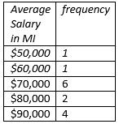
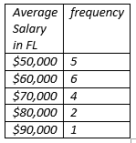
83. The table below represents salaries of residents in
Michigan and Florida.

Which state had the higher median? ______________

What is the median salary in the
state with the higher median? ______________

Which state had the higher mean? ______________

What is the mean salary in the
state with the higher mean? ______________

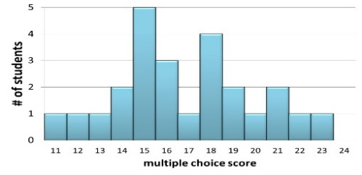
Students’ Scores in 2016
Students’ Scores in 2015

84. How many fewer students scored a 15 in 2016?

85. What was the average score in 2015? In 2016?

86. What was the median score in 2015? In 2016?

