What Is The Angle Measure? and More Review
Directions: In #1-5 find all of the missing angles.
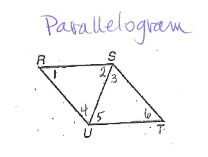
Parallelogram
1. Given that m<1 = 15 and m<3 = 85 for the parallelogram, find the following angles:
m<2 = _____________ m<4 = ________________
m<5 = _____________ m<6 = ________________

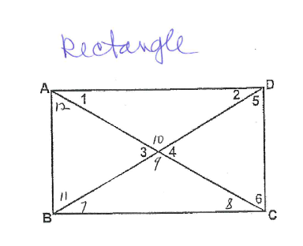
Rectangle
2. Given that m<1 = 35 and for the rectangle, find the following angles:
m<2 = _________ m<3 = ____________
m<5 = _________ m<6 = ____________
m<7 = _________ m<8 = ____________
m<9 = _________ m<10 = ___________
m<11 = _________

Square
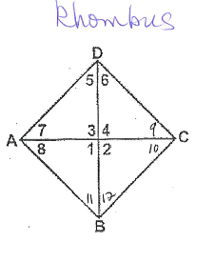
3. Given the m<9 = 30 for the rhombus, find the following angles:
Rhombus
m<1 = ____________ m<2 = ________________
m<3 = ____________ m<4 = ________________
m<5 = ____________ m<6 = ________________
m<7 = ____________ m<8 = ________________
m<10 = ___________ m<11 = _______________
m<12 = ___________
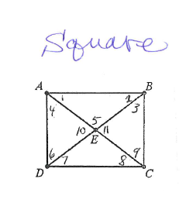
4. Given that the shape is a square, find the following angles:
Square
m<1 = ______________
m<2 = _______________ m<3 = __________________
m<4 = _______________ m<5 = __________________
m<6 = _______________ m<7 = __________________
m<8 = _______________ m<9 = __________________
m<10 = ______________ m<11 = _________________

Identifying Properties: In problems 6-13 below, list the letters of the quarilaterals that the properties hold true for:
a) Parallelogram b) Rectangle c) Rhombus d) Square

6. Diagonals bisect each other. 7. All <’s are right <’s

8. All sides are congruent. 9. Opposite sides are congruent.

10. Opposite angles are congruent. 11. Diagonals are congruent.

12. Diagonals are perpendicular. 13. Opposite sides are parallel.

14. ABCD is a rhombus. If m<8=35°, 15. ABCD is a rectangle. If m<1=20° find the
Find the measure of <1, <2, <3, <4, measures of <2, <3, <4, <5, <6.
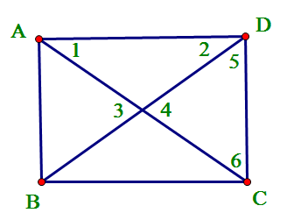
<5, <6, <7.
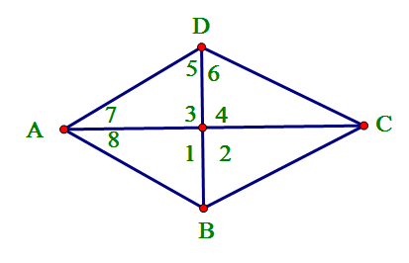

16. ABCD is a square. If AC=16in and 17. ABCD is a parallelogram. AR= 2x+ 3,
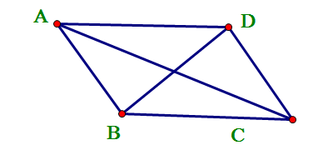
BD = 2x + 4, find x. RC= 35, BR= 4y – 10, DR= 90. Find x and y.
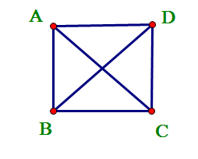
R

23. ACT QUESTION!
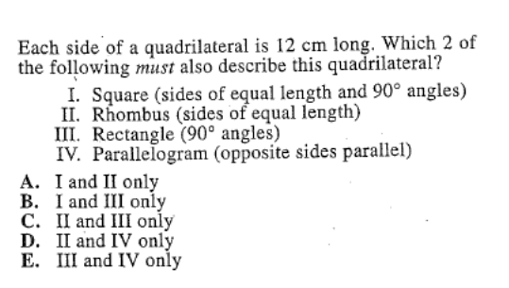

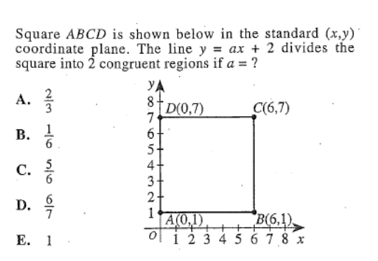
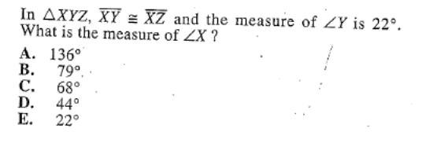
24. ACT QUESTION! 25. ACT QUESTION!

