**Trigonometry Test Review 2017**

*All work must be shown for full credit. This includes showing work for  
 multiple choice problem and includes drawing pictures for problems that need them.* **Make sure your calculator is in the correct mode.   
If it is not stated, round all final answers to the nearest tenth or nearest degree.**

**For each of the pictures below, state what method below you use to find the missing side:   
Pythagorean Theorem, 45-45-90 Shortcut, or 30-60-90 Shortcut  
You *do not* need to solve!**

1.______________________________ 2. _____________________________

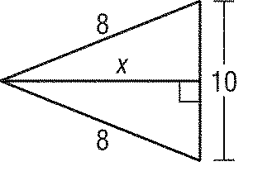

3. _____________________________ 4. _______________________________



5. Find *x* to the nearest tenth.

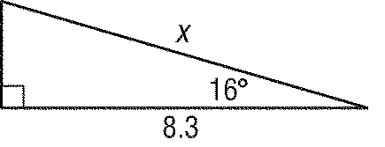

2.3

6. An A-frame house is 45 feet high and 32 feet wide. Find the measure of the angle that the roof makes with the floor. Round to the nearest degree.

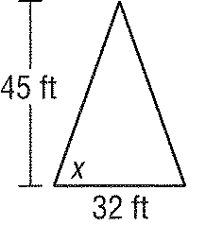

7. A plane flying at an altitude of 20,000 feet begins descending when the end of the runway is below a point 80,000 feet away. Find the angle of descent (depression) to the nearest degree.

8. Find the value of *x* in the figure below.



9. Beth is measuring the height of a tree. She stands 37 feet from the base of the tree. The angle formed by the ground and the line to the top of the tree is  Find the height of the tree.



10. The angle formed by the base and the line to the top of a waterslide is about  The slide extends horizontally about 65.4 meters. Find the height *h* of the slide.



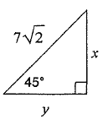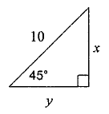11. Find the missing side length(s) below. Make sure you are using the correct method to solve.

a)  b) c)

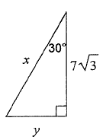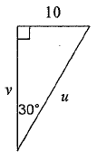

d) e) f)

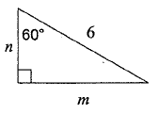

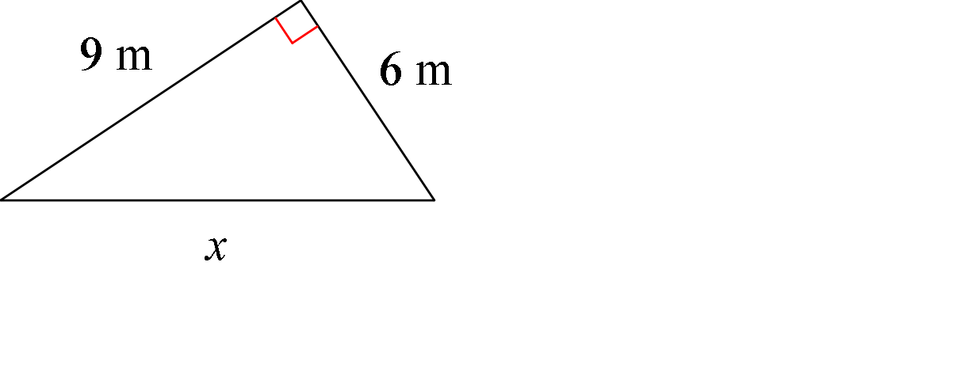g) h) i)

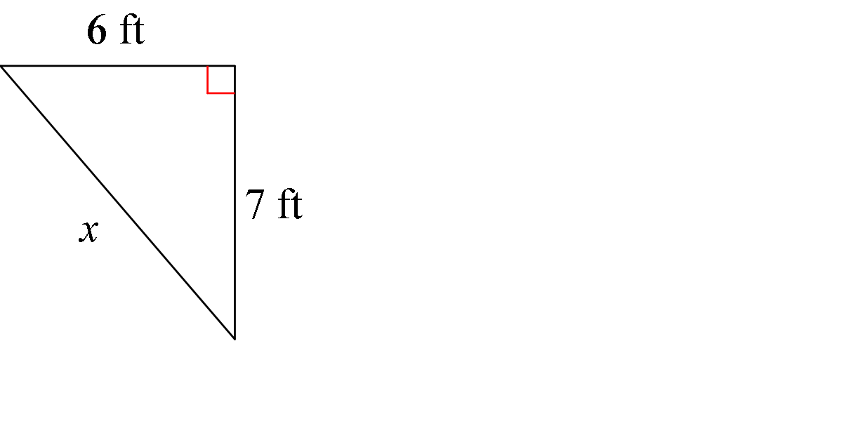

j) Given the square below, find x and y. k) l)

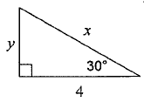

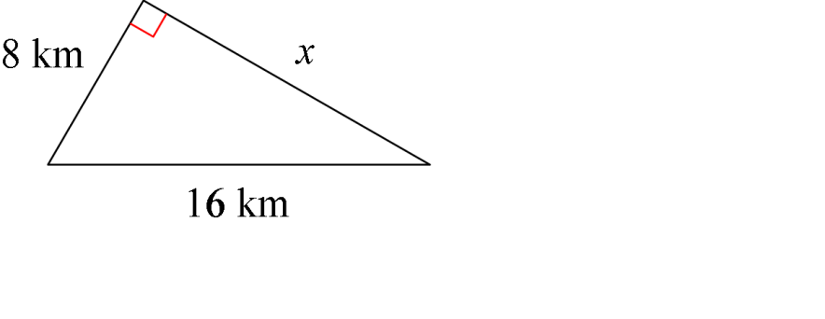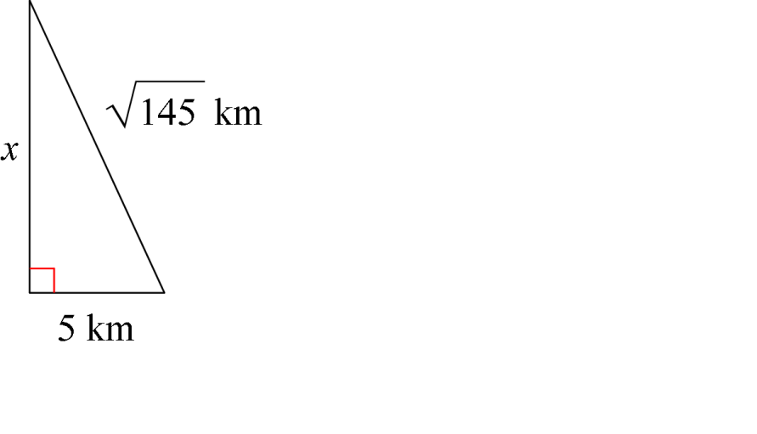m) n)

12. A 45-foot tree casts a 18-foot shadow. Find the angle of elevation of the sun to the nearest degree.

13. A boat is 1000 meters from a cliff. If the angle of depression from the top of the cliff to the boat is 12°, how tall is the cliff? Round your answer to the nearest tenth.

14. Find x (Hint: we do not know the angles)



15. Which set of measures below could represent the sides of a right triangle?

1. 5, 12, 13

1. 
2. 7, 17, 24
3. 8, 15, 16
4. 8, 10, 12
5. 4, 2, 3
6. 9, 15, 12
7. 11, 7, 14

16. Find the perimeter of a square if the length of its diagonal is 16 mm.

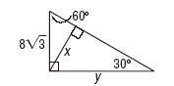17. Find x and y.

x = ________

y = ________

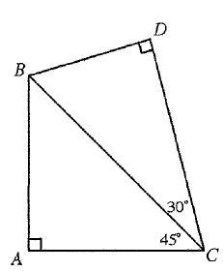18. If AC = 10 in the figure below, find BD.

19. Find *x, y* and *z.*

x = _________

y = _________

z = _________

**Multiple Choice**

*Identify the choice that best completes the statement or answers the question.*

____ 20. Find sin *B* in *ABC*.

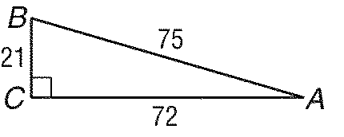

|  |  |  |  |
| --- | --- | --- | --- |
| a. |  | c. |  |
| b. |  | d. |  |

____ 21. Find *y* to the nearest tenth.

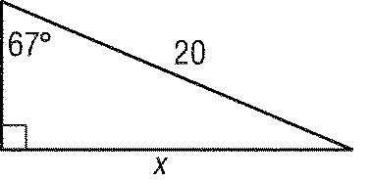

y

|  |  |  |  |
| --- | --- | --- | --- |
| a. | 7.8. | c. | 18.4 |
| b. | 17.3. | d. | 47.1 |

____ 22. Find the angle of elevation of the sun when a pole 25 feet tall casts a shadow 42 feet long.

|  |  |  |  |
| --- | --- | --- | --- |
| a. | 30.8° | c. | 53.5° |
| b. | 36.5° | d. | 59.2° |

____23. Find *x*.

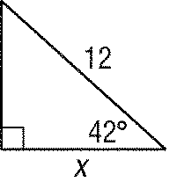

12

|  |  |  |  |
| --- | --- | --- | --- |
| a. | 8.0 | c. | 13.3 |
| b. | 8.9 | d. | 10.8 |

____24. Find *x* to the nearest degree.

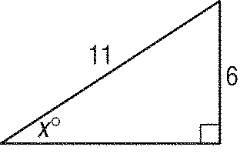

17

8

|  |  |  |  |
| --- | --- | --- | --- |
| a. | 57 | c. | 33 |
| b. | 55 | d. | 28 |

____ 25. If a 30-foot ladder makes a 50° angle with the ground, how many feet up a wall will it reach? Round your answer to the nearest tenth.

|  |  |  |  |
| --- | --- | --- | --- |
| a. | 38.4 ft | c. | 22.9 ft |
| b. | 20.8 ft | d. | 12.7 ft |

____ 26. A ski slope is 250 yards long with a vertical drop of 100 yards. Find the angle of depression of the slope.

|  |  |  |  |
| --- | --- | --- | --- |
| a. | 21.8° | c. | 66.4° |
| b. | 23.6° | d. | 68.2° |

____ 27. A bird watcher spied a woodpecker. The bird watcher is 40 yards lower than the woodpecker. The distance from the bird watcher to the woodpecker is 175 yards. What is the angle of elevation?

|  |  |  |  |
| --- | --- | --- | --- |
| a. | 12.9° | c. | 76.8° |
| b. | 13.2° | d. | 77.1° |

____ 28. Two swimmers are observed by a lifeguard in a 30-foot tower above the water. The angles of depression are 12.7° and 14.5°. How far apart are the swimmers?

|  |  |  |  |
| --- | --- | --- | --- |
| a. | 16.6 ft | c. | 116.0 ft |
| b. | 133.1 ft | d. | 17.1 ft |

____ 29. After flying at an altitude of 500 meters, a hang glider starts to descend when the ground distance from the landing pad is 15 kilometers. What is the angle of depression for this part of the flight? (15km =15000m)

|  |  |  |  |
| --- | --- | --- | --- |
| a. | 1.7° | c. | 88.1° |
| b. | 1.9° | d. | 88.3° |

3.

30. In the right triangle below, if , what is What is (Do not find the angle measure)

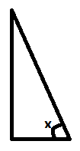

31. In the right triangle below, if , what is What is (Do not find the angle measure)

