Name: _____________________________________________________________
Trig Functions of General Angles HW (Degrees)

To find the EXACT trigonometric values Notes
1.) Sketch the angle
2.) Label the reference angle
3.) Draw a triangle to the x-axis and label sides
4.) Find the trig values

Recall that the radius is one because we are working with the unit circle.
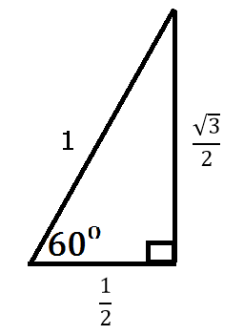
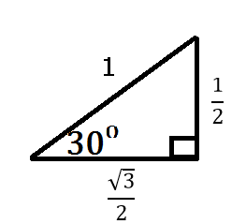
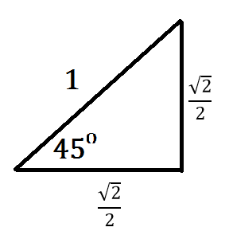

1. Find the exact value of sin 135ᵒ. 2. Find the exact value of cos 60ᵒ.

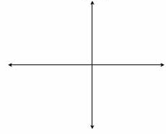

3. Find the exact value of sin 150ᵒ. 4. Find the exact value of tan 315ᵒ.

5. Find the exact value of cos 330ᵒ. 6. Find the exact value of tan 240ᵒ.

7. If $cosθ=\frac{\sqrt{3}}{2}$ and in quadrant I, complete the following:
a.) Construct the triangle on the coordinate plane.
b.) Find the value of the reference angle in degrees.
c.) Find the length of the missing side.
d.) Find the value of sin .

a.) b.) Reference angle `=

c.) missing side length =

d.) sin =

8. If $sinθ=-\frac{1}{2}$ and in quadrant IV, complete the following:
a.) Construct the triangle on the coordinate plane.
b.) Find the value of the reference angle in degrees.
c.) Find the length of the missing side.
d.) Find the value of cos .

a.) b.) Reference angle `=

c.) missing side length =

d.) cos =

