Name __________________________

**Similarity- Practice Test**

1. Determine if the 2 triangles are similar. If so, by which postulate and complete the similarity statement? Justify your answer!!!! Hint: mark your picture.

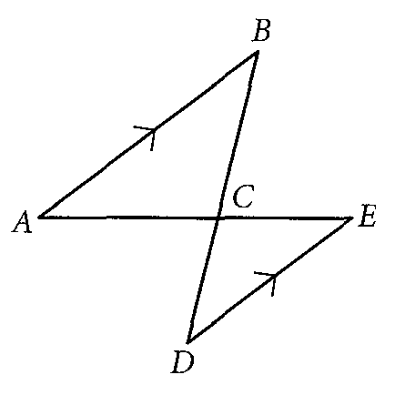 ∆ABC~∆______ Shortcut: ______

2. Determine if the 2 triangles are similar. If so, by which postulate and complete the similarity statement? Justify your answer!!!! Hint: mark your picture.

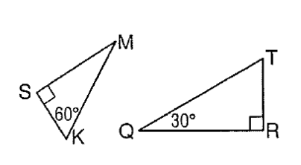

∆TRQ~∆______ Shortcut: ______

3. If there is 16 players on the JV tennis team and 21 players on the freshman tennis team, what is the ratio of the students on the freshman team to the JV team?

4. In a triangle, the ratio of measures of 3 sides is 5:12:13 and the perimeter is 120 inches. Find the measure of the *shortest* side.

5. QPR ~ OMN

Find a, b, and c if the perimeter of MON is 45 inches. All measurements are in inches. **SHOW ALL YOUR WORK.**



**a = _________**

**b = _________**

**c = _________**

6. Given that mA = mD and mC= mF, find x and y. (Round to the nearest whole number if necessary.) **SHOW ALL YOUR WORK.**



x = _______

y = _______

7. . Find the values of x and y. **SHOW ALL YOUR WORK.**



**x = ______**

**y = ______**

8. Anna wants to find the height of the tallest building in her city. She stands 384 feet away from the building. There is a tree 31 feet in front of her that is 20 feet tall. How tall is the building to the nearest foot? **SHOW ALL YOUR WORK.**



x =________

9. A building casts a shadow 138 meters long. At the same time, a pole 3 meters high casts a shadow 9 meters long. What is the height of the building? **SHOW ALL YOUR WORK.**

y = _______

10. ABC is shown on the grid. Two coordinates for a second triangle are also shown on the grid at (-7, -3) and (-7, -4). Using the provided information, what coordinates will create another triangle that is similar to ABC?



[A] (-1, -3)

[B] (-6, -3)

[C] (-5, -4)

[D] (-3, -4)

12. Determine whether parallelograms QRSP and TUVW are similar. **Explain why or why not**.



13. Are ABC and FDE similar? Justify your answer.



14. Explain the situation in which two similar triangles could be congruent.

15. Draw the image of ∆JKL under a dilation with center C and a scale factor of 2.

K

J

● C

L

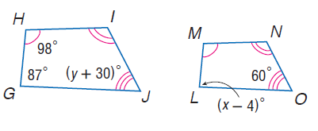16. Find x and y for the similar polygons below. Circle your final answer.

17. Find the value of the variable and the lenth of each side if the following triangles are similar.

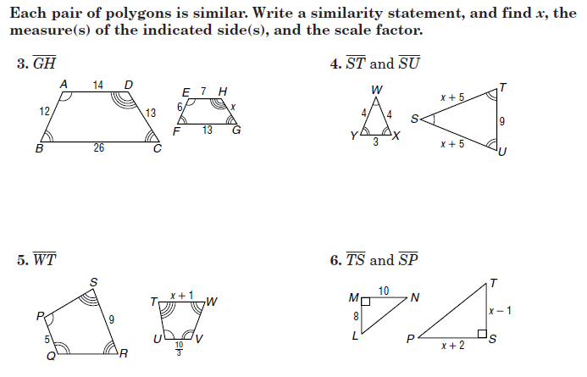

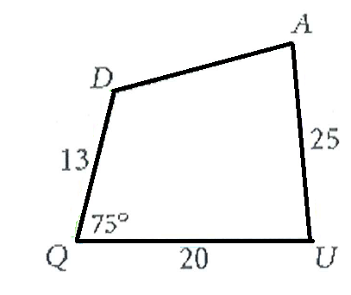

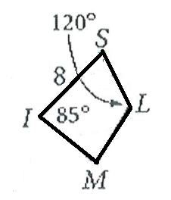

18. Find the measurements

SL = _______

MI = _______

_______

_______

_______

19. Find x.

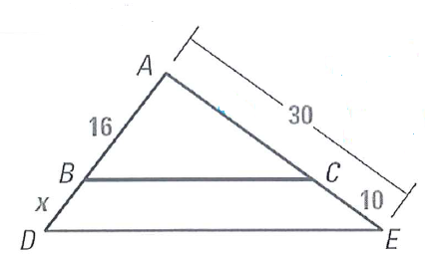

20. If *ABC*  *DEF*, find *m*<*C*. m<C = __________

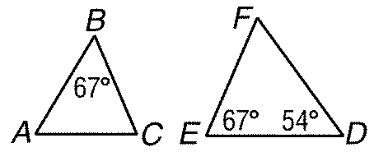

21. Find x for these two similar triangles.

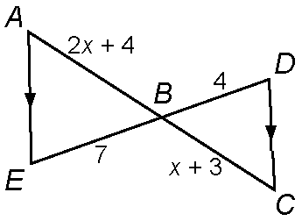

22. The local fire academy is practicing evacuating a hotel. Two teams are going through two windows. Window one, 12 feet above the ground and the other "z” ft above the ground. They are using a 20ft ladder to get to the lower window and a 50ft ladder to get to the higher window. Find the distance between the short ladder and the base of the building (x), the distance between the two ladders (y) and how far the 2nd window is above the ground. Keep answer in feet and round to the nearest tenth if needed.

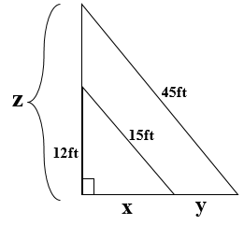

50ft

20ft

x = ______________

y = _______________

z = _______________

How much further does the 50 foot ladder reach than the 20 foot ladder?