Segment (and Angle) Relationships Homework #1

Find the value of x and SR if R is between S and T. Justify steps!
1. $SR=3x, RT=2x+1, ST=6x-1$ 2. $SR=5x-3, ST=7x+1, RT=3x-1$

Find the value of the variable and ST if S is between R and T. Justify steps!
3. $RS=2x, ST=3x, RT=25$ 4. $RS=16, ST=2x, RT=5x+10$

5. $RS=3y+1, ST= 2y, RT=21$

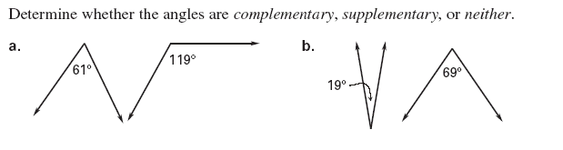
6.

7.

Decide whether the statement is true or false. If the statement if false, reword the statement so it is true.

8. Two angles are complementary if the sum of their measures is 180°
.

9. Two angles are supplementary if the sum of their measures is 180°

10. Two angles are adjacent angles if they share a common vertex.

Determine whether the angles are complementary, supplementary or neither.
11. 12. 13.

Find the measure of the complement of the given angle.
14. 15. 16.

Find the measure of the supplement of the given angle.
17. 18. 19.

20. Find x and the measure of $\overline{JK}$if K is the midpoint of $\overline{JL}$. Show work.
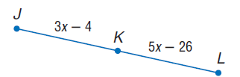

Find the value of the variable and QR if Q is between P and R. Justify steps!
21. $PQ=1-x, QR=4x+17, PR=-3x$

22. $PR=7n+8, PQ=4n-3, QR=6n+2$

