Name: ____________________________________________ Hour: _________
Proportion Review Homework

- The male to female ratio in a particular country is 52 to 48. Write this ratio as a fraction in reduced form.

- Find the ratio of the perimeter of rectangle BCDA to the perimeter of rectangle KLMJ.
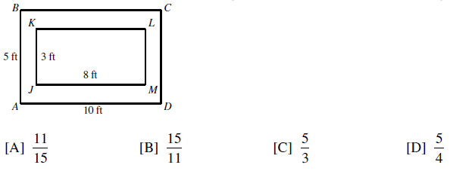

Solve the following proportions! You must show all work in order to receive credit! Simplify all answers (you may use decimals).
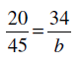
3.

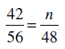

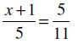

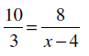

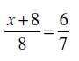
7.

8. $\frac{y+5}{5}$ = $\frac{6}{y-2}$

9.$\frac{m+3}{4}$ = $\frac{11}{m-4}$

10.$\frac{2}{p+4}$ = $\frac{p+5}{3}$

11.$\frac{n+4}{3}$ = $\frac{-3}{n-2}$

Solve the following proportions! You must show all work in order to receive credit! These will be checked!! Simplify all answers (you may use decimals).

12. A bus travels 80 miles on 4 gallons of gas. Write and solve a proportion to determine the number of gallons needed to travel 300 miles.

13. On a blueprint, the scale indicates that 6 centimeters represent 15 feet. What is the length of the room that is 14.4 centimeters long and 5 centimeters wide on a blueprint?

