**Perimeter Ratios and Indirect Measurement Examples**

1. The perimeter of ABC = 54 inches and the perimeter of APQ = 18 inches.

ABCAPQ. Find a, b, x, y, and z.

|  |  |
| --- | --- |
|  | a = ____________  b = ____________  x = ____________  y = ____________  z = ____________ |

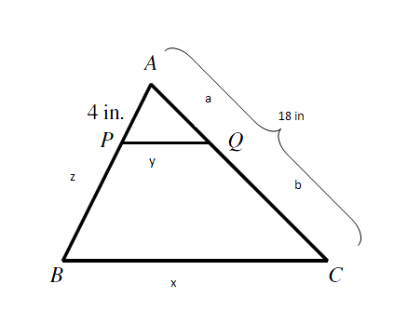

PR



2.

a = ____________

b = ____________

c = ____________

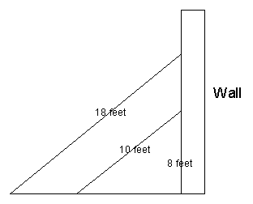

3. Romeo is trying to see his Juliet but the only way to do so is to climb through her window. Her window is 16.2 feet off the ground. He leans two ladders against the wall such that they make the same angle with the ground. He knows his 13 foot ladder is too short because it only reaches up 8 feet. He has an idea to use his 21 foot ladder, but he is unsure if the ladder will reach. Round to the nearest tenth if needed.

21ft

13ft

**How high does the 21 foot ladder reach?** ___________________

**How much further does the 21 foot ladder reach than the 13 foot ladder? ______________**

4. The local fire academy is practicing evacuating a hotel. Two teams are going through two windows. Window one, 12 feet above the ground and the other "z” ft above the ground. They are using a 30ft ladder to get to the lower window and a 75ft ladder to get to the higher window. Find the distance between the short ladder and the base of the building (x), the distance between the two ladders (y) and how far the 2nd window is above the ground. Keep answer in feet and round to the nearest tenth if needed.

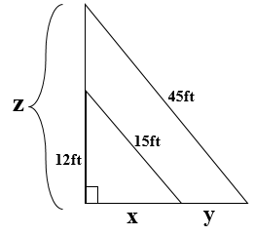

75ft

30ft

x = ______________

y = _______________

z = _______________

5.The two triangles below are similar. Find a, b, and c if the perimeter of the small triangle is 21in. Find the perimeter ratio of the larger triangle to the smaller triangle first. Round to the nearest tenth if needed.

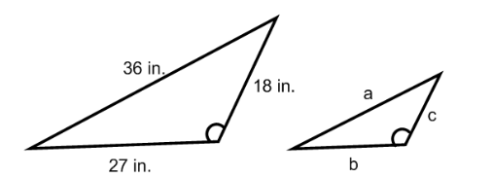

PR= ________________

a = __________

b = __________

c = __________



6. Romeo is trying to see his Juliet but the only way to do so is to climb through her window. Her window is 16.2 feet off the ground. He leans two ladders against the wall such that they make the same angle with the ground. He knows his 14 foot ladder is too short because it only reaches up 8 feet. He has an idea to use his 30 foot ladder, but he is unsure if the ladder will reach. Round to the nearest tenth if needed.

30ft

14ft

**How high does the 30 foot ladder reach?** ___________________

**How much further does the 30 foot ladder reach than the 14 foot ladder? ______________**