Name: _________________________________________ HOUR: _____________Due Date: __________________

2016 Geometry Midterm Review

Directions: This review consists of problems that could be on your midterm. Make sure you complete each problem and **show your work.**

1. For equilateral ∆RST, find the variable and the side lengths. All units are in inches.

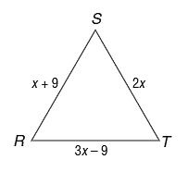

1. For isosceles ∆RST, find the variable and the side lengths. All units are in centimeters.

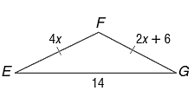

1. Find the missing angle measures, *m*<1 and *m*<2.

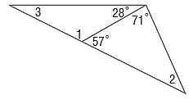

1. Find the missing angle measures.

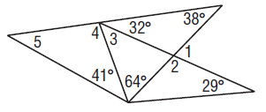

1. Find the missing angle measures.

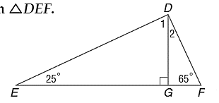

1. What are the missing coordinates of the isosceles triangle?

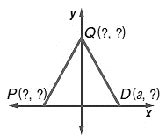

1. 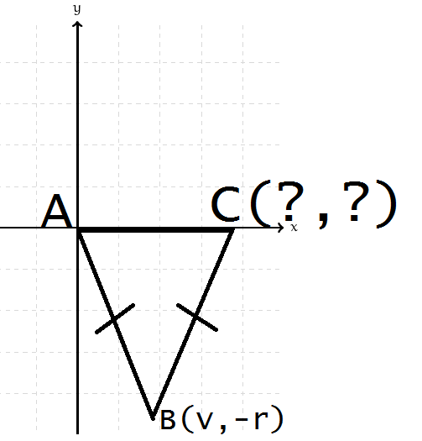What are the missing coordinates of this isosceles triangle?
2. If FH is a median of ∆EFG, find the perimeter of ∆EFG, then state 3 true things about this figure.

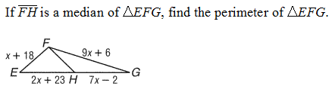P = ________

1) __________________________________________

2) __________________________________________

3) __________________________________________

1. Find x.

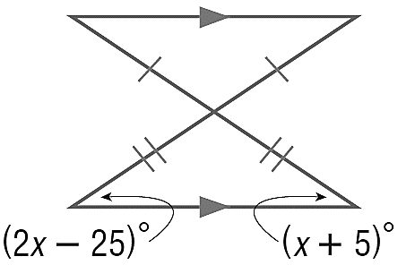

1. In the figure below, B is on , E is on ,  is parallel to , and  is congruent to .. Name the legs of the isosceles triangle, name the base angles and vertex angle of the isosceles triangle, and provide an example of an exterior angle. What is the measure of <DEB and <EBF?

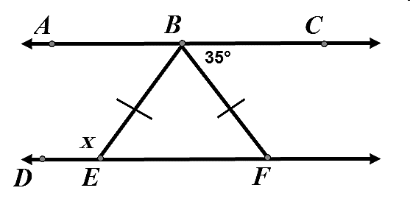

1. Identify the triangle ∆CAB is congruent to, then name all corresponding parts. There should be 6 pairs.

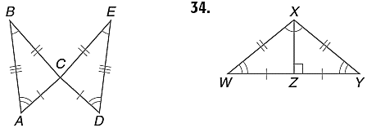

1. Identify the triangle ∆XZW is congruent to, then name all corresponding parts. There should be 6 pairs.



1. Write a two-column proof.

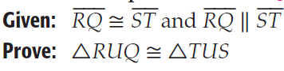

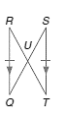

1. Write a two-column proof.

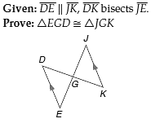

1. Write a two-column proof.

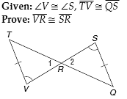

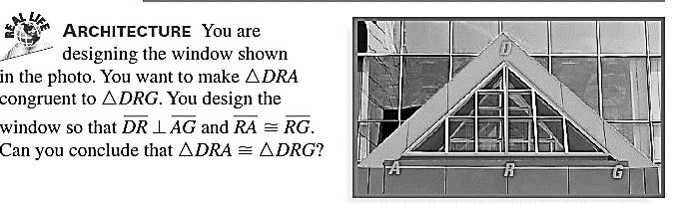

1. Write a two column proof using the stingray below.

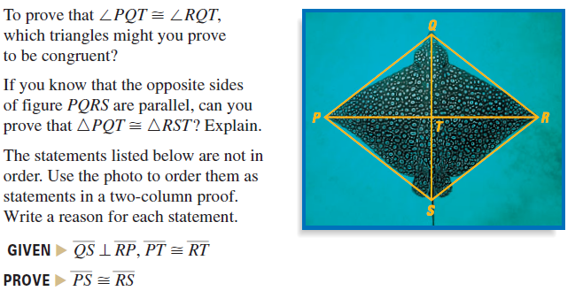

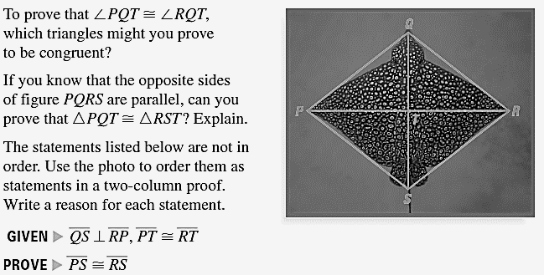

1. 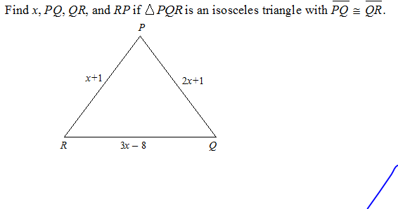
2. **BASEBALL** Alan, Brendon, and Carl were standing in a triangular formation shown. They were throwing the baseball to warm up for the game. Find the value of x, the measure of each angle and then conclude what two people must throw the farthest distance.

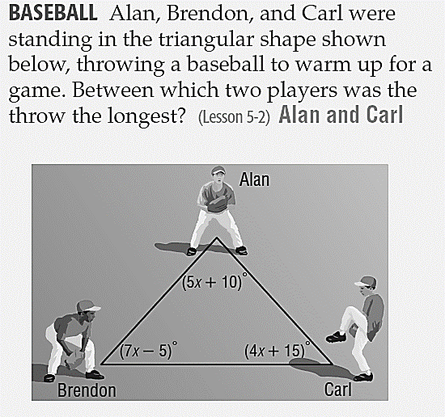

1. A ladder is 15ft long and reaches 10 feet up a wall, as shown in the picture. How many feet is the bottom of the base of the wall?

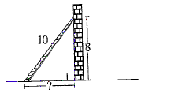

10 ft

15 ft

1. 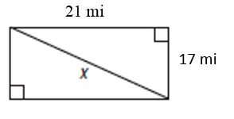Find the value of x.
2. 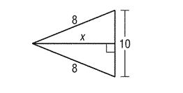 Find x.
3. 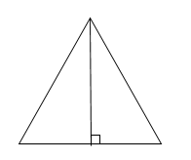 Find x if the triangle is an equilateral triangle whose sides are 20 cm long.

20 cm

x

1. Find the slope, distance, and midpoint between each set of points.

A) points S and T.

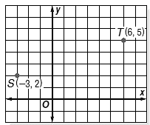 Distance: __________________

Midpoint: __________________

Slope: ______________________

b) G(2,6), H(-1,4) Distance: __________

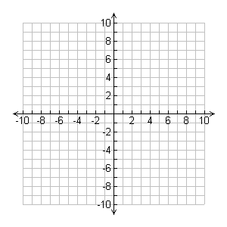 Midpoint:___________

Slope: _____________

c) J(7,10), K(-4,5) Distance: __________



Midpoint:___________

Slope: _____________

d) D(0,2), E(4,5) Distance: __________



Midpoint:___________

Slope: _____________

1. 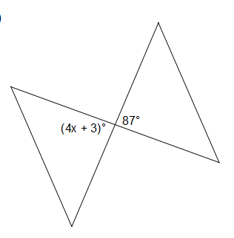Find the value of x, y, and z.

y

z

1. What is the degree measure of the larger of the two angles?

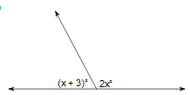

1. 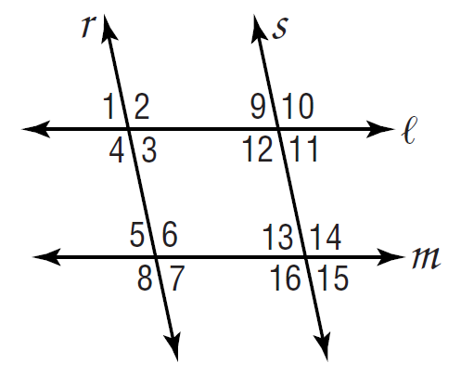 a) Given *l || m,* name the relationship that makes $∠10≅∠16$?

b) Given *r || s,* name the relationship that makes $∠3+∠12=180°$?

c) If $∠11≅∠15,$ what 2 lines are parallel?

d) If $∠2≅∠6,$ what 2 lines are parallel?

e) If $∠9≅∠13,$ what 2 lines are parallel?

1. 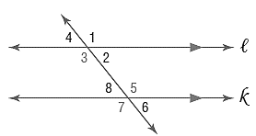Find x so that lines l and k are parallel, given $<2=27x+2$ and $<5=18x-2$.
2. Find x so that lines l and k are parallel, given $<4=17x$ and $<6=-5+18x$.
3. Name all the relationships that allow us to say l is parallel to k.

$<1≅<7$ proves $l||k$ because

$<2≅<8$ ________________________

proves $l||k$ because

$<3≅<7$ ________________________

proves $l||k$ because

$<3+<8=180$ ________________________

proves $l||k$ because ________________________

1. Find x, then the length of EF. Show your work, geometry and justify your set up!

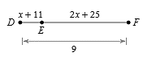

1. AC and BD bisect each other at point M. Find x, y, and BM. Show your work, geometry and justify your set up!

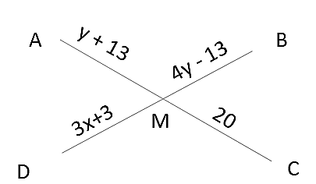

1. Find all the missing angle measures.

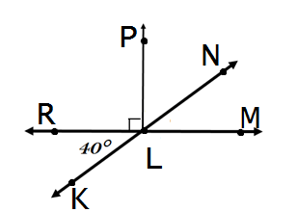 $m∠NLM= ______________________$

$$m∠NLP= ______________________$$

$$m∠MLK= ______________________$$

$$m∠NLR= ______________________$$

$$m∠PLM= ______________________$$

1. Given the following triangle with angle bisector MK state if the following statements are true or false.

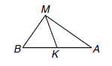a. $m<MKA = 90ᵒ$

b. $\overline{BK} ≅ \overline{AK}$

c. $m<BMK = m<AMK$

d. ∆BMA is isosceles with vertex angle M.

1. Given that the following are parallelograms, find x.

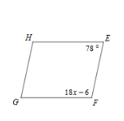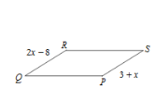a. b.

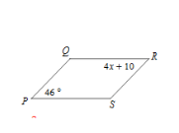

c.

a. Suppose VWXY is a rectangle and b. Suppose ABCD is a square and

XV= 4x - 9 and WY = x + 3, AC = 9y – 8 and BD = 7y +8.

find x and WM. Find y and AC.

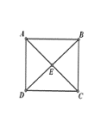 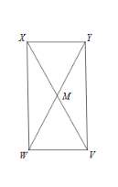

1. 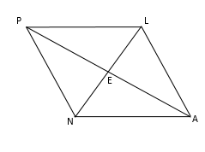 **Use rhombus PLAN to write the correct geometric statement (if needed) and justification**.

a.) AL PL because :___________________________________________________

b.) <NEA = 90 because :___________________________________________________

c.) EA __________ because :___________________________________________________

d.) NA // __________ because :___________________________________________________

e.) <NPE __________ because :___________________________________________________

f.) <PLA __________ because :___________________________________________________

g.) <LNA __________ because :___________________________________________________

h.) <LEA = 90 because :____________________________________________________________

1. **Use rectangle RECT to write the correct geometric statement (if needed) and justification.**

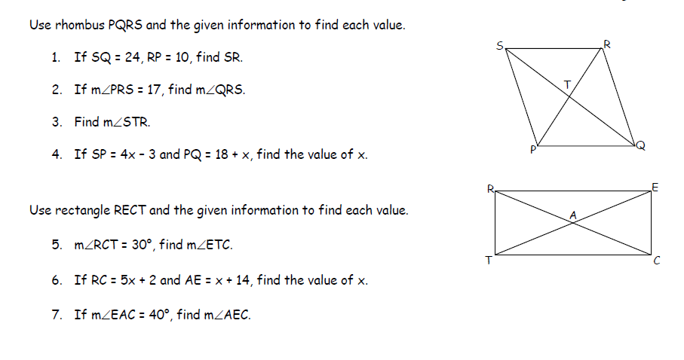a.) RC TE because :_______________________________ ____________________

b.) <TCE = 90 because :___________________________________________________

c.) EA __________ because :___________________________________________________

d.) RE // __________ because :___________________________________________________

e.) <TRA <RTA because :___________________________________________________

f.) <RAE __________ because :___________________________________________________

g.) <RTE <TEC because :___________________________________________________

h.) <TCR + ________ = 90 because :____________________________________________________________

1. a. $ABCD$ is a rectangle with $B\left(5, -3\right), C\left(5, -6\right),$ and $D(9, -3)$. Find the coordinates of $A.$

b. $ABCD$ is a rectangle with $B\left(10, 7\right), C\left(10, 4\right),$ and $D(8, 4)$. Find the coordinates of A.

1. Given the set of vertices, determine if it is a parallelogram or not. If it is a parallelogram, determine whether it is a rectangle. Explain why or why not.

a.

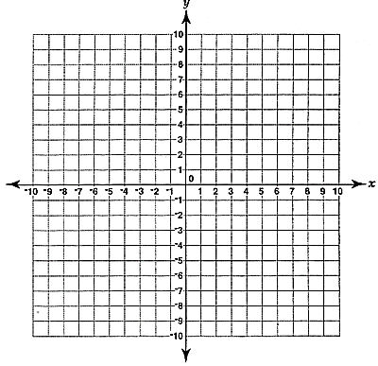

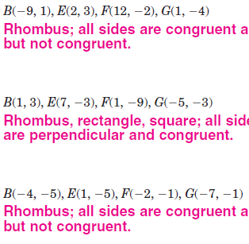

b.

1. For the parallelogram below, find m< 1 if m<K=118.

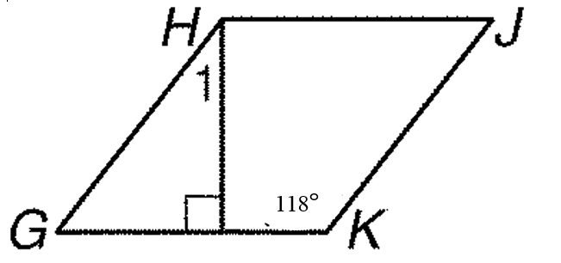

1. If  and triangle ABC is reflected over line m first, then line n, what transformation would occur from $∆$ ABC to $∆$ A”B”C”?



a. reflection

b. dilation

c. rotation

d. translation

1. If LMNO is reflected over line k first, then line m, what transformation would occur from LMNO to L”M”N”O”?

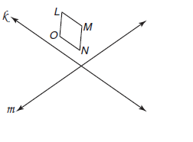

a. reflection

b. dilation

c. rotation

d. translation

1. Given point A(6, -1), find its image if it is reflected across the x-axis, the y-axis, y = x, y = -x
2. Given the point (x, y), write the image point if it is reflected across the x-axis, the y-axis,

y = x, y = -x

1. What is the original point of Y’(-2, 4) under the translation (x,y) $→$ (x + 5, y)?

1. What is the point of X’ if X(2, 5) is under the translation (x,y) $→$ (x - 1, y + 2)?

1. Symmetry: How many lines of symmetry does a(n) ….
   1. Square have? ________
   2. Rectangle have? ________
   3. Isosceles Triangle have? ________
2. Graph the image of the figure with 50. Graph the image of the figure with a   
   a reflection across y = 2 reflection across y = x

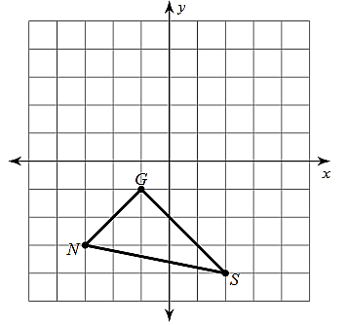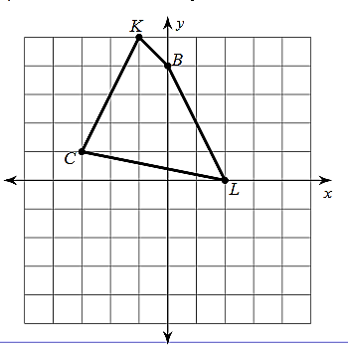

51. Graph the image of the figure 52. Graph the image of the figure with a   
with a rotation $90°$ counterclockwise rotation $90°$ clockwise about the origin.

about the origin.

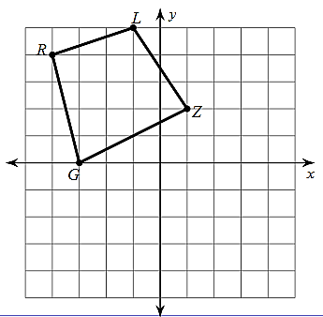

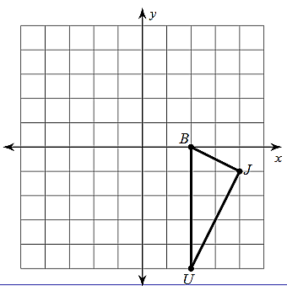

53. Identify each statement as true or false.

a) The diagonals of a parallelogram are always congruent.

b) A parallelogram is always a square.

c) The diagonals of a rectangle sometimes bisect each other.

d) The diagonals of a rectangle always bisect the angles.

e) The diagonals of a square are never perpendicular bisectors of each other.

f) A rhombus is always a rectangle.

g) A square is never a rectangle.

h) A square is always a rhombus.

i) Opposite angles in a parallelogram are always congruent.