Homework: Line Segments and Angles
The Basics
Directions: Illustrate the following.

1. X is the midpoint of $\overline{AB}$ 2. $\overset{⃡}{AB}$ is a ⊥ bisector of $\overline{GH}$

3. <ABC and <CBD are linear pairs 4. Line d is an angle bisector
of < LMN

5. $<WXY≅<JKM$ 6. $\overline{PM}≅\overline{ED}$

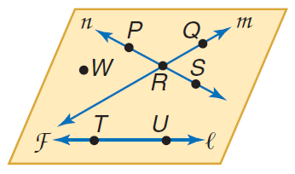

Directions: Refer to the figure.

7. Name a line that contains point P.

8. Name the plane containing lines n and m.

9. Name the intersection of lines n and m.

10. Name a point not contained in line l, m, or n.

11. What is another name for line n?

12. Does line l intersect line m or line n? Explain.

