Converse of the Pythagorean Theorem & Special Right Triangle HW
Directions: Determine if the set of measures below a) form a right triangle and
b) are a Pythagorean Triple.
1) 30, 40, 50 2) 20, 30, 40 3) $\frac{3}{7},\frac{4}{7},\frac{5}{7}$

- ________ a) ________ a) ________
- ________ b) ________ b) ________

4) $\sqrt{5}, \sqrt{12}, \sqrt{13}$ 5) 9, 40, 41

- ________ a) ________
- ________ b) ________

Directions: Find the missing variable(s) in each problem.
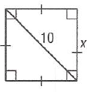
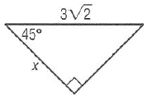
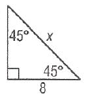
6) 7) 8)

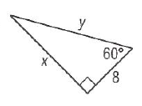
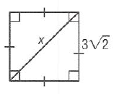
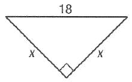
9) 10) 11)

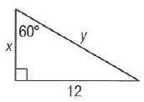
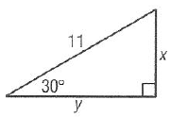
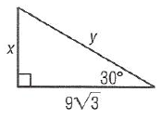
12) 13) 14)

For the following 4 problems, find what it asks you to. If you are stuck, draw a picture to help yourself!
15) Find the perimeter of a square with diagonal 12 cm.

16) Find the diagonal of a square with perimeter 20 inches.

17) The perimeter of an equilateral triangle is 33 cm. Find the length of an altitude of the triangle.

18) An altitude of an equilateral triangle is $5\sqrt{3}$ meters. Find the perimeter of the triangle.

